Experiment-5

NAME :T PAVAN

ROLL NO : 224G1A0567

# Aggregate functons(min,max,count,sum,avg)

To perform the aggregate functions you need to create a table and insert values in it

For example we can take a table name called employee

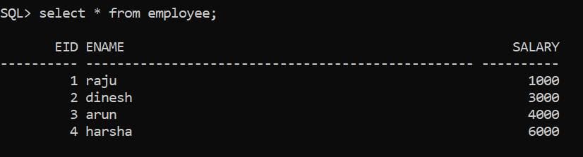

# Min function

It is used to find the minimum value int the column of a table

For example we are performing the above aggregate functions in the example.

## Syntax :

Select min(column_name) from table_name;

Ex:

Select min(salary) from table_name;

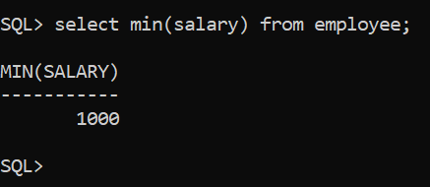

# Max function :

It is used to find the maximum value int the column of a table.

## Syntax:

Select max(column_name) from table_name;

Ex:

Select max(salary) from employee;

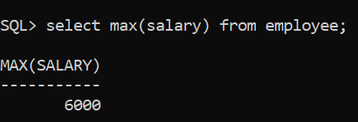

# Count function :

It is used to count the how many rows in the column of a table.

## Syntax:

Select count(column_name) from table_name;

Ex:

Select count(salary) from employee;

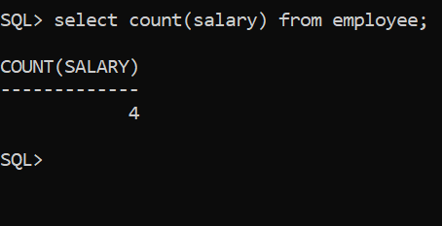

# Sum function :

It is used to find the sum of the values in a row of a table.

# Syntax :

Select sum(column_name) from table_name;

Ex:

Select sum(salary) from employee;

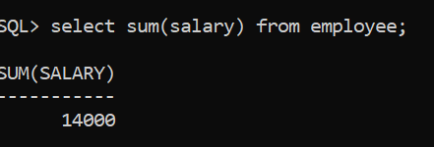

# Avg function :

It is used to find the average of the column of a table.

# Syntax:

Select avg(column_name) from table_name;

Ex:

Select avg(salary) from employee;

